Denver Performing Arts Complex MVP
Denver, CO

Project Details
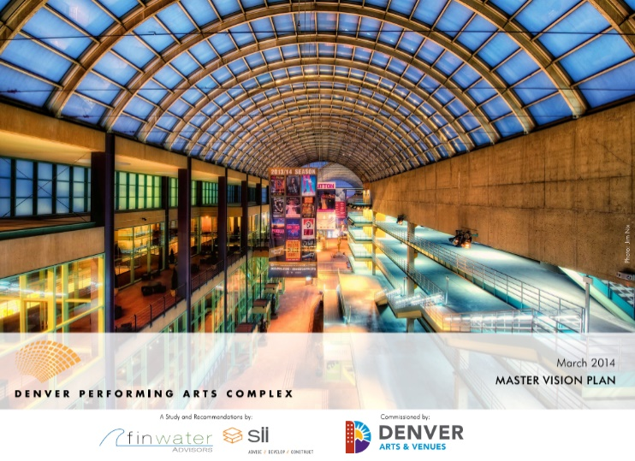
Description: 2-Phase Master Planning Study
Owner: City of Denver, Arts & Venues
Partner: Finwater Advisors
Completion: March, 2014

Project Description
Between May 2013 and March 2014, SII was engaged in partnership with Finwater Advisors by Denver’s Division of Arts and Venues (A&V) to design and perform a two-phase analysis and master planning study of the Denver Performing Arts Complex (DPAC). The goals of the study were:
- To analyze the future of the Colorado Symphony Orchestra at Boettcher Concert Hall and explore their relocation to the Ellie Caulkins Opera House;
- Investigate the current trajectory of usership and patronage at DPAC and understand where strategic changes may broaden the patron demographic;
- Research successful governance structures around the country and study their relevance to the Denver market and potential benefits to DPAC and A&V of their adoption;
- Assess the built environment and outline capital improvement strategies that may enhance the patron experience, draw new audiences and increase venue utilization, and ultimately drive overall complex revenues.
The final deliverable of the study, termed the Master Vision Plan (MVP), is being used by Arts and Venues to market their transformation strategies for DPAC both within the City and to the broader Denver community, with the ultimate goal of realizing the vision outlined in the document.
Scope of Work
In partnership with Finwater Advisors, SII was integrally involved in all aspects of the two-phase study. Responsibilities included:
- Assessing the programmatic needs of the Symphony and evaluating the schedule and programmatic constraints of the Ellie Caulkins Opera House and its primary tenants (Colorado Ballet and Opera Colorado).
- Researching comparable complexes around the country and analyzing best practices related to governance, revenue development and sharing, systemic industry challenges and built environment improvements.
- Working with Arts & Venues, DPAC staff and the Resident Companies to understand their programmatic needs and business challenges and concerns with the Complex.
- Organizing the findings and assembling them into cohesive, thoughtful and relevant recommendations that are realistic and implementable.

